Low Back Pain Exercise Guide
Regular exercises to restore the strength of your back and a gradual return to everyday activities are important for your full recovery. Your orthopaedic surgeon and physical therapist may recommend that you exercise 10 to 30 minutes a day 1 to 3 times a day during your early recovery. They may suggest some of the following exercises. This guide can help you better understand your exercise and activity program, which should be supervised by your therapist and orthopaedic surgeon.
Red Flag symptoms
These are symptoms which warrant urgent assessment, usually at the A&E dept
- Complete loss of power to the leg [not just painful to move]
- Loss of sensation [pins and needles] which does not resolve.
- Loss of control of bowels or bladder [usually with loss of sensation around the groin]

These can indicate pressure on the spinal cord [cauda equina syndrome]

Initial Exercise Program

Ankle Pumps
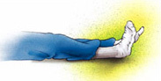
- Lie on your back.
- Move ankles up and down. Repeat 10 times.
- Repeat 10 times.

Heel Slides
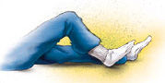
- Lie on your back.
- Slowly bend and straighten knee.
- Repeat 10 times.

Abdominal Contraction
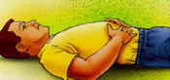
- Lie on your back with knees bent and hands resting below ribs.
- Tighten abdominal muscles to squeeze ribs down toward back.
- Be sure not to hold breath.
- Hold 5 seconds.
- Relax.
- Repeat 10 times.

Wall Squats
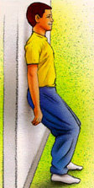
- Stand with back leaning against wall.
- Walk feet 12 inches in front of body.
- Keep abdominal muscles tight while slowly bending both knees 45 degrees.
- Hold 5 seconds.
- Slowly return to upright position.
- Repeat 10 times.

Heel Raises
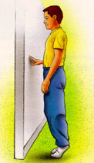
- Stand with weight even on both feet.
- Slowly raise heels up and down.
- Repeat 10 times.

Straight Leg Raises
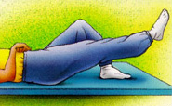
- Lie on your back with one leg straight and one knee bent.
- Tighten abdominal muscles to stabilize low back.
- Slowly lift leg straight up about 6 to 12 inches and hold 1 to 5 seconds.
- Lower leg slowly.
- Repeat 10 times.
Intermediate Exercise Program

Single Knee to Chest Stretch
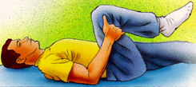
- Lie on your back with both knees bent.
- Hold thigh behind knee and bring one knee up to chest.
- Hold 20 seconds.
- Relax.
- Repeat 5 times on each side.

Hamstring Stretch
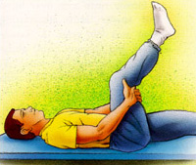
- Lie on your back with legs bent.
- Hold one thigh behind knee.
- Slowly straighten knee until a stretch is felt in back of thigh.
- Hold 20 seconds.
- Relax.
- Repeat 5 times on each side.

Lumbar Stabilization Exercises With Swiss Ball
Abdominal muscles must remain contracted during each exercise (see Abdominal Contraction). Perform each exercise for 60 seconds. The farther the ball is from your body, the harder the exercise.

Lying on Floor
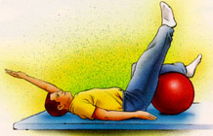
- Lie on your back with knees bent and calves resting on ball.
- Slowly raise arm over head and lower arm, alternating right and left sides.
- Slowly straighten one knee and relax, alternating right and left sides.
- Slowly straighten one knee and raise opposite arm over head. Alternate opposite arms and legs.
- Slowly "walk" ball forward and backward with legs.

Sitting on Ball
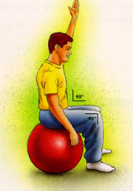
- Sit on ball with hips and knees bent 90°and feet resting on floor.
- Slowly raise arm over head and lower arm, alternating right and left sides.
- Slowly raise and lower heel, alternating right and left sides.
- Slowly raise one heel and raise opposite arm over head. Alternate opposite arm and heel.
- Marching: Slowly raise one foot 2 inches from floor, alternating right and left sides.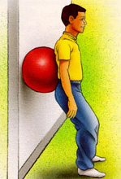
- Standing
- Stand with ball between your low back and wall.
- Slowly bend knees 45 ° to 90 ° . Hold 5 seconds. Straighten knees.
- Slowly bend knees 45 ° to 90 ° while raising both arms over head.

Lying on Ball
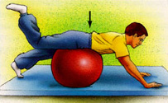
- Lie on your stomach over ball
- Slowly raise alternate arms over head.
- Slowly raise alternate legs 2 to 4 inches from floor.
- Combine 1 and 2, alternating opposite arms and legs.
- Bend one knee. Slowly lift this leg up, alternating right and left legs.
NOTE: Be careful not to arch your low back!

Advanced Exercise Program

Hip Flexor Stretch
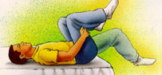
- Lie on your back near edge of bed, holding knees to chest.
- Slowly lower one leg down, keeping knee bent, until a stretch is felt across top of the hip/thigh.
- Hold 20 seconds.
- Relax.
- Repeat 5 times on each side.

Piriformis Stretch
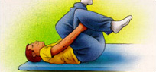
- Lie on back with both knees bent.
- Cross one leg on top of the other.
- Pull opposite knee to chest until a stretch is felt in the buttock/hip area.
- Hold 20 seconds.
- Relax.
- Repeat 5 times each side.

Lumbar Stabilization Exercise With Swiss Ball
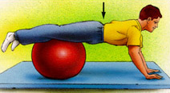
- Lie on stomach over ball.
- " Walk " hands out in front of ball until ball is under legs. Reverse to starting position.
- " Walk " hands out in front of ball until ball is under legs and slowly raise alternating arms over head.
- " Walk " hands out in front of ball and slowly perform push-ups.

Aerobic Exercises
Maintain spine in neutral position while stabilizing with abdominal muscles to protect the low back during aerobic exercise.
- Stationary bike for 20 to 30 minutes.
- Treadmill for 20 to 30 minutes.

